

Informatique & Mathématiques Appliquées
UNIVERSITE
JOSEPH FOURIER
Sciences, Technologie, Médecine
Grenoble 1

TD4: Use Cases

1. ATM: Actors and Stakeholders
You have been hired to create the requirement document for the software of a new ATM. Decide whether each item in the following list is a stakeholder, a primary actor, a secondary actor, an intermediary actor, the system under design, or not an actor at all.
- The ATM machine
- The ATM software
- The customer
- The credit card
- The bank (institution)
- The front panel
- The bank owner
- The technician maintaining the software
- The printer
- The bank information system
- The bank teller
- The bank robber
- The ATM machine: an intermediary actor
- The ATM software: the system under design
- The customer: a primary actor
- The credit card: an intermediary actor
- The bank: not an actor (stakeholder)
- The front panel: intermediary actor
- The bank owner: not an actor (stakeholder)
- The technician: a primary actor (if some functions are made for him, otherwise or a secondary actor (if he is called in case of problems) or just a stakeholder
- The printer: a secondary actor
- The main bank computer system: a secondary actor
- The bank teller: not an actor (not even a stakeholder)
- The bank robber: not an actor (possibly a stakeholder!)

Important points:
- do not confuse actors and stakeholders
- do not confuse roles (actors) and persons
2. Actors and Stakeholders
Personal Trader, inc. is coming out with a new product that will allow people to manage stock portfolio. The product (PAF for Personal Advisor Finance) comes on a CD. The user installs it and then runs various financial scenarios to learn how to optimize his portfolio future. PAF can interrogate various tax packages, such as TaxSoftware for tax laws. TaxSoftware is automatically installed in the user computer with PAF. It allows to calculate taxes on any transaction, depending on the country of the user.
Personal Trader, inc. also set up an agreement with WebStock to directly buy and sell stocks over the net. PAF allows the easy creation of account on WebStock.

Name and identify the PAF’s actors.

TraderAtHome: the individual using the software to manage his portfolio
Administrator: the individual installing and maintaining the software
Tax package: the complementary software interacting with PAF (PAF is the initiator)
Web stock services: Web services interacting with PAF (PAF is the initiator)
Update center: pushes updates (or event and they the software pulls)

We may add an actor called “Printer”.

The bank is not an actor: we make the hypothesis that the bank is called by the web stock services.
The personal computer is generally not mentioned as an actor (it is an intermediary action which is not represented).

3. Use case diagram
Propose a use case diagram identifying the PAF main use cases.

Important use cases:
- Install PAF
- Update PAF
- Notify Update
- Uninstall PAF
- Log In
- Log Off
- Open Account
- Credit Account
- Close Account
- Calculate current status
- Sell Stocks
- Buy Stocks
- Simulate Sells
- Simulate Buys
- Run simulation (buy and sell stocks)

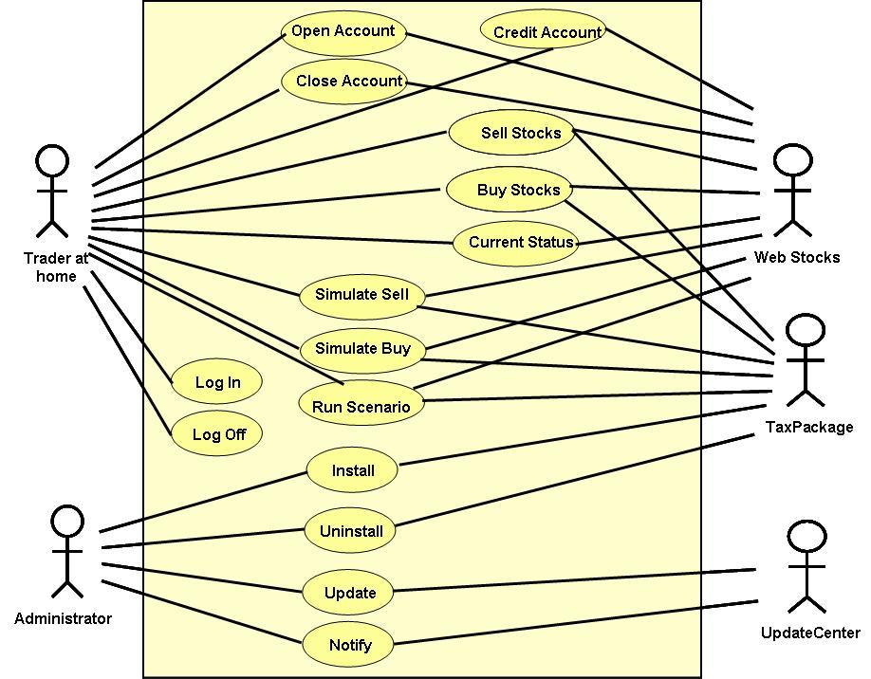4. Use case
Select a major PAF use case and propose a detailed description, including:
- pre-conditions
- main actions
- post-conditions
- exception

Use case “Open Account”

Pre-condition: TraderAtHome is logged, maximum number of account not reached
Actions:
- Press button “Create Account”
- The system sends a request to WebStock
- WebStock asks for name, id, pwd, bank id
- TraderAtHome provides the information
- The system sends the requested information
- WebStock sends a confirmation
- The system asks TraderAtHome if he wants information to be saved
Exception:
- Invalid information

